Appendix 15: SWIFT Interview Guide: Referral Services




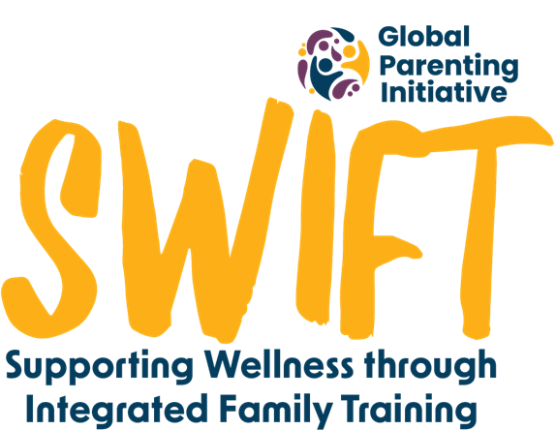


Briefing:

Hi there. Thank you for making the time for this phone call; it won’t take longer than 30 minutes. ParentText provides contact information for other services in the community, for example, substance abuse, mental health, and domestic violence. We asked to speak with you because we saw that you accessed and interacted with the ‘help’ menu in ParentText. We want to know more about your experience with this.

We will be recording this phone call, so we can remember your answers, but your name and your answers will be kept confidential and will only be viewed by the research team. After the interview, the recording will be transcribed, or written down, and then it will be deleted. The written down information will be saved securely on a password protected computer. Do I have your permission to record the interview?

There are no right or wrong answers. You can skip any questions you do not feel comfortable answering. You can also stop this conversation at any time if you wish. If you decide at a later stage that you would like your contribution to be removed from the study, you can contact the research team by email until the [date to be determined].

Do you understand what I’ve just explained? Do you have any questions? Can we begin?
- As I mentioned, we see that you used the help menu in the ParentText programme a few times. What about this help menu made you want to access it a number of times?
- What did you find helpful?
- Was there anything more you wish it had?
- Did you only access the help menu while you were working through the lessons? If no - how did you use the help menu after working through the content?
- One of the referral categories was for help with mental health. While working through the programme, did you try to find more information on any of the mental health numbers or organisations? Why or why not?
- Another one of the referral categories was for help with violence prevention. While working through the programme, did you try to find more information on any of the violence prevention numbers or organisations? Why or why not?
- Which other services did you want to find more information on while using the chatbot? (e.g. for SASSA or for school support)
Probe: Would you feel comfortable to share with me why you needed contact information for any of those services? Did it help?
- Which of the services did you actually use in the help menu? Which organisations did you contact directly, and what was your experience accessing or getting through to these organisations?
- There were some links to websites which we thought might be helpful - Was the information helpful? Correct? Easy to access?
- Did you use the WhatsApp lines for anything? How did you find it?
- Did you call any of the service providers and make an appointment or go in? How did you find this?
- Did you find out about any services which you didn’t know about before?
- Were there any of the links or contacts which didn’t work? (e.g. disconnected/broken links etc)
- Can you tell me about the quality of your experience with the service providers you contacted? (ensure they answer this question for every referral organisation they contacted)
- Probe: Were they able to help you? Why/why not?
- Probe: What could have made them more helpful?
- Probe: Did you access them in person? Why or why not?
- Do you have any suggestions for how we could improve the ‘help’ menu in the programme?
Debriefing

Is there anything that we haven’t spoken about that you’d like us to know?

If there was anything that made you feel worried or unsettled while doing this interview, remember you can still access the referrals in the programme by typing ‘help’. SADAG might be a good option. If you have any other questions about the study, you can also send us a WhatsApp or email. Our contact information is on the consent form we sent you.
We’ve come to the end of our interview. Thanks again for taking the time to speak with us today. Your responses have been very helpful!

